**

**GUILDHALL SURGERY AND PPG NEWSLETTER**

**WINTER 2023**

**SURGERY UPDATE**

The Surgery is excited to welcome the following new staff members:-

* Sarah Bloomfield – Reception Manager
* Janine Smith – Receptionist
* Lisa Barlow – Receptionist
* Jan Murphy – Accounts Administrator
* Gemma King – Health Care Assistant

…and we said goodbye recently to our Practice Manager, Dawn Reader and Lead Practice Nurse Katy Cowling who have worked at the Surgery for many years. We wish them both well in their new jobs and thank them for their contributions over the years.

…we are pleased to welcome our new Lead Practice Nurse to the team, Jodie Hammond who will be joining us again.

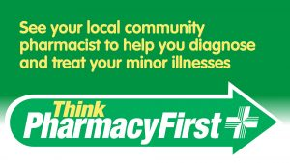**WINTER PRESSURES / APPOINTMENTS / CONSENT**

As winter approaches, the Surgery prepares for the increase of coughs, colds, sore throats and respiratory infections. The majority of these are caused by viral infections and do not require antibiotics or a GP visit. In the first instance please do seek advice from your local pharmacist. If your cough/cold lasts longer than 3 weeks (or sooner if you have underlying health conditions such as autoimmune disease), please call the Surgery.

If you contact us for an appointment, our care navigators / reception team triage requests and will ask you for a description of your symptoms; **THIS IS AT THE GP’S REQUEST** and will assist in enabling them to provide you with the right appointment and treatment with the most appropriate member of our clinical team.

If you need to act **ON BEHALF OF ANOTHER PERSON** or discuss their care with us, we will need form 'Consent to Disclose Health Information' completed by the person *and* witnessed by a 3rd party. The form is available in the ‘Further Information_ Data Protection & Patient Health Record Information’ section of our website. Alternatively a copy of the form can be collected from reception. **WITHOUT** consent on an individual’s Health Record, **NO** members of our team will be able to disclose information or discuss patient care.

**WEBSITE**

Please visit our website for a host of additional information, forms and links:-

Details are provided on how to register for GP online services; the NHS app can be used to view your medical information, request medication as well as making appointments.

If you have a health concern or medical condition and wish to receive advice, guidance or treatment, you can always send us an ‘E’ consult request (see icon). This is especially useful for repeat medical certificates (i.e. sick notes).

**HOME VISITS**

If you are housebound and require a home visit, then it is important that you telephone the Surgery **BEFORE 11AM**. You will still be asked for a description of your symptoms and in some cases a clinician may also telephone you prior to a visit for further details.

**LONG TERM CONDITIONS**

If you have diagnosed long term condition/s (e.g. arthritis, asthma, diabetes, epilepsy, angina, heart failure, high blood pressure), the Surgery will be in touch to make an appointment for your annual review (by month of birth order). In some cases, blood test results will be required prior to the review and if necessary, a blood test form will be provided for you to book directly.

**IMPORTANT – MEDICATION REVIEWS**

For patients on regular medication, it is really important you have an annual review with one of our nurses or clinical pharmacist team. This is to ensure your medication is current and up to date and enable you to continue to request repeat prescriptions. If you have not had this appointment please be aware that your prescription request may be delayed. You may also be required to have an annual blood test before this appointment. When booking please advise the prescribing or reception team the date your blood test has been booked for so they can arrange your review following this. (The date your medication review is due is shown on your repeat prescription form/s.)

**INFECTION CONTROL & COVID 19**

Guidance from the government and NHS regarding infection control measures in the Surgery have not changed but we urge all patients to be vigilant with their hand hygiene; hand gel is still available in reception. At any time in the waiting room we may have elderly patients or those people with a weakened immune system, so if you have any of the below symptoms we ask that you please **DO NOT** attend the Surgery and instead request a telephone appointment.

COVID-19 symptoms can include:

* a high temperature or shivering (chills) – a high temperature means you feel hot to touch on your chest or back (you do not need to measure your temperature)
* a new, continuous cough – this means coughing a lot for more than an hour, or 3 or more coughing episodes in 24 hours
* a loss or change to your sense of smell or taste
* shortness of breath
* feeling tired or exhausted
* an aching body
* a headache
* a sore throat
* a blocked or runny nose
* loss of appetite
* diarrhoea
* feeling sick or being sick

See - <https://www.nhs.uk/conditions/covid-19/covid-19-symptoms-and-what-to-do/> for latest information.

**HOT TOPICS & GOODBYE** *by**Katy Cowling, Previous Lead Practice Nurse*

It is with a heavy heart that I am saying farewell to everyone at the Guildhall Surgery after more than 9 years, to move to pastures new.

I would like to take this opportunity to thank all the staff, clinicians and patients who I have worked with over these years. My work has been both hard and challenging, especially through the dark days of Covid-19, but mostly it has been incredibly rewarding and satisfying and I hope I have made a small difference to the care of the patients here at the Guildhall Surgery.

The New Year brings resolutions and hopes that we can improve our health. You may have been invited to come for a NHS health check via our partner Provide.

You are eligible for the **NHS Health Check** if you’re aged 40 to 74 and do not have a pre-existing health condition (see more at [https://www.nhs.uk/conditions/nhs-health-check//](https://www.nhs.uk/conditions/nhs-health-check/)). You should be invited to an NHS Health Check by your GP or local council every 5 years, so please do attend if you have been invited.

At your appointment you'll be given your cardiovascular risk score of developing a heart or circulation problem, such as heart disease, stroke, type 2 diabetes or kidney disease, over the next 10 years. At the appointment you'll have the chance to discuss your results and how to improve your scores, through lifestyle changes, including where you can get support.

I wish you all Good Health, a Merry Christmas and a Happy New Year.

**VACCINATIONS**

Influenza

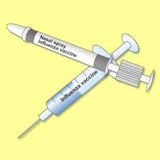These are still being provided for anyone over the age of 65 or under the age of 65, but included in an 'at risk' category.

If you think you may be eligible, please call the Surgery for our team to assist you and arrange an appointment if necessary.

Children aged 2 and 3 years (but not aged 4 on/by 31st August 2023) along with those aged between 6 months and 17 years with an underlying health condition, will be called for nasal flu vaccinations at the Surgery.

School aged children (Reception to Year 11) should get an invitation via their school for vaccination. If your child misses this or they are home-schooled, they should be offered a flu vaccine via community clinic:-

Suffolk Community and School Age Immunisations Service  
Telephone Number: 0300 555 5055 (Option 4) – 8m to 4pm  
Email: [hct.csaissuffolk@nhs.net](mailto:%20hct.csaissuffolk@nhs.net)  
Follow us on Twitter: [@SuffolkImmsTeam](https://twitter.com/suffolkimmsteam?lang=en)

For more information visit:- <https://www.nhs.uk/conditions/vaccinations/child-flu-vaccine/>

Pneumonia

Everyone over the age of 65 and those with certain underlying medical conditions will be called for a pneumonia vaccination.

Shingles

The new Shingles vaccination programme started on 1st September which means all of those eligible will be receiving a two dose course of vaccination. This is different from previous years due to a change in the vaccination we use. **Those who have received a previous dose of shingles vaccine** **do not require another**.

The programme is being rolled out in stages based on age groups and to those who have a lowered immune system. We will be calling in patients for this and will be doing this in a systematic way to allow for the allocated and restricted amount of vaccinations we can order at a time. See below:

If you have a severely weakened immune system you will be eligible for shingles vaccine from 50 years of age.

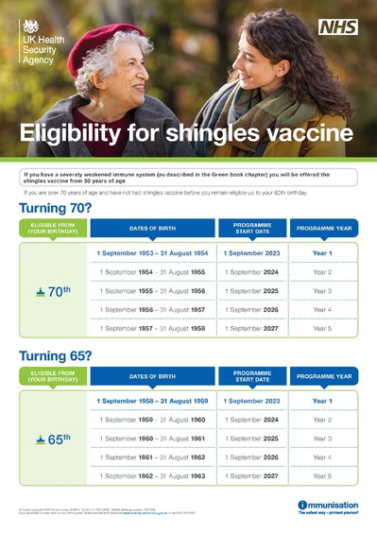

**FEEL GOOD SUFFOLK**

A new approach to improving health and wellbeing in Suffolk.

Feel Good Suffolk launched on 2 October, providing a completely new approach to improve the health and wellbeing of Suffolk people, including support to stop smoking, manage weight and to be more physically active.

Feel Good Suffolk is a partnership between local councils and health colleagues working together with voluntary and community sector organisations and others, building on close links with communities to offer greater choice and flexibility of services to meet the needs of residents.

Get help and support and lots of useful tips, advice and resources @ <https://feelgoodsuffolk.co.uk/>. Alternatively you can also contact their our customer service advisors on 0345 603 4060.

**DEMENTIA**

As a Surgery we recognised that many of our patients have Dementia, Alzheimer's or some other cognitive disability. Following the assessment carried out by the Sue Ryder Dementia Together team, we made and will continue to make improvements around our unique building to be more user friendly:-

***"Dementia Together****, led by Sue Ryder takes a community asset-based approach working in partnership with a number of organisations. These include statutory services, the voluntary sector and local community groups, with a view to simplifying the pathway for people needing support, making the most of and building on support available and encouraging growth in local support and information available."*

**PATIENT PARTICIPATION GROUP (PPG)**

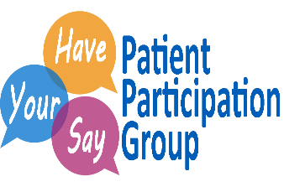Our **PPG** helps to communicate to us the views and perceptions from our patients of the services that we provide as well as ideas about how we could improve our service. Our Facebook page is very active and we are making it more interactive. We always have feedback surveys in the Surgery in paper form, which can be completed when you next come into us. We also like to encourage our patients to visit the Facebook and Website for information and updates regarding the Surgery and general health information and news.

**PRESCRIPTION REQUESTS**

If you wish to order repeat medications, you can do this by requesting in writing and posting in the Surgery post box by the side entrance, or you can order your repeats online, once you have registered for on-line access.

Please allow at least 2 working days after submission before contacting/collecting at your nominated pharmacy. Please also allow additional time over bank holidays.

**PRESCRIPTION QUERIES**

If you have a query regarding your prescription or medication please select the option for our dedicated PRESCRIPTION LINE from the Surgery's main telephone number. The line is open between 10:00 and 13:00 each working day. Alternatively, you can leave a message on their answering service and they will call you back. Please DO NOT direct prescription queries to our reception team as they will not be able to help you.

**SAMPLES**

If you have been asked by one of our team to supply a urine, stool, sputum sample etc., please ensure these are back to the Surgery before **11:00am**.

**USEFUL INFORMATION**

Contact Times:-

|  |  |
| --- | --- |
|  | Monday - Friday |
| Opening Times | 08:00 – 18:30 |
| Surgery Times | 09:00 – 12:00 & 15:30 – 18:00 |
| Reception Telephone Lines | 08:30 – 13:00 & 14:00 – 18:30 |
| Prescriptions | 10:00 – 13:00 |
| Secretarial / Reports | 14:00 – 16:00 |
| Test Results | 15:00 – 17:00 |

**WHEN THE SURGERY IS CLOSED:-**

Integrated Care Board (ICB) Training Events Closures:-

* 12:30pm Wednesday 07 February until 8:00am Thursday 08 February 2024
* 12:30pm Wednesday 24 April until 8:00am Thursday 25 April 2024
* 12:30pm Wednesday 10 July until 8:00am Thursday 11 July 2024
* 12:30pm Wednesday 18 September until 8:00am Thursday 19 September 2024
* 12:30pm Thursday 21 November until 8:00am Friday 22 November 2024
* If you need advice for any minor ailments, please see your local Pharmacist.
* If you require urgent medical attention, please contact 111.
* If you have a life threatening medical emergency please call 999 immediately.

Useful Websites:-

|  |  |
| --- | --- |
| Guildhall Surgery website | [www.guildhallsurgery.co.uk](http://www.guildhallsurgery.co.uk) |
| Find us on Facebook | <https://www.facebook.com/GuildhallsurgeryClare/> |
| Government COVID 19 | <https://www.gov.uk/coronavirus> |
| Flu injections | [www.nhs.uk/conditions/vaccinations/flu-influenza-vaccine/](http://www.nhs.uk/conditions/vaccinations/flu-influenza-vaccine/) |

***Wishing you all a very happy Christmas and a safe and healthy 2024***

***The Guildhall Surgery Team***